Monthly Health & Wellbeing Column
Music Teacher Magazine
March 2023

Music and Accountability
Accountability sits uncomfortably on many shoulders. In our capacity as teachers, we must manage our pupils, resources, our planning and expectations. Busy early years music educators often rush from one at different developmental age group to the next, with many being non-verbal. Accountability hovers even as we engage with our respective communities, often emerging when something unexpected occurs.

Preconceptions
What do we know about the children that we teach? What do we know about the setting, their resources, the carers, the setting's ethos? Why do they want music lessons from an external provider? Is all this relevant to mental health and wellbeing? In this context the adage 'fail to prepare, prepare to fail' carries far more weight. Be accountable!

All too often I hear "I'm not given any information due to data protection". Do not wait to be told. Make it your priority to find out as much as you can from the top dog. A good starting point is to ask, "tell me about your children to help me provide outstanding music lessons". You will gain mutual respect since ultimately; we all want the best for our children. This knowledge will help you connect with the setting's ethos. You would reduce anxiety by knowing that every child is properly supported through music and be in a stronger position all round. Bespoke (lesson plans) is the new adaptable, helps carers to acknowledge individual responses for their assessment criteria, and will ultimately save you time and potential redundancy. For music educators a little reading on early childhood pedagogy is an added skill. Early Education is a good place to start.

Cultures and bias
The information you are given will be an important snapshot of your children from which you should be open to new discoveries as you go along. Many years ago, I taught at a private setting. There were 15 children with one carer in a small room. Over the weeks I frantically used every educational straw to retain control over of seemingly privileged 2-3 year olds climbing the wall, pulling resources off the table, running round in circles screaming and generally being anarchic. My mental health deteriorated, I dreaded Wednesdays and felt like an utter failure when I resigned. What went wrong? The problem was me. I had not enquired about the children's background, the setting's ethos or what they wanted. I later realised that many were from different cultural environments, some spoke no English and had significant needs. My template should have accounted for less resources, more topic based movement and interaction. Useful information on cultural diversity is available via the government website.

Resources or not?
How many times have we over-loaded on resources to maximise musical offerings to young children? In some cases, when monitoring teachers in action I observed anxiety, stress and even fear. One example involved using several tactile resources at once - puppets, scarves, instruments and bubbles! The teacher sang at heightened pitch, taught at a mildly frantic speed and hid behind her guitar. Everyone had a great time. But did they? The teacher looked frazzled and there was a notable lack of spontaneity and shared musicianship. After the lesson we reflected and picked the lesson plan apart. With support the teacher considered her musical objectives, removed several resources and gave both herself and her beneficiaries more time and space to really experience music.

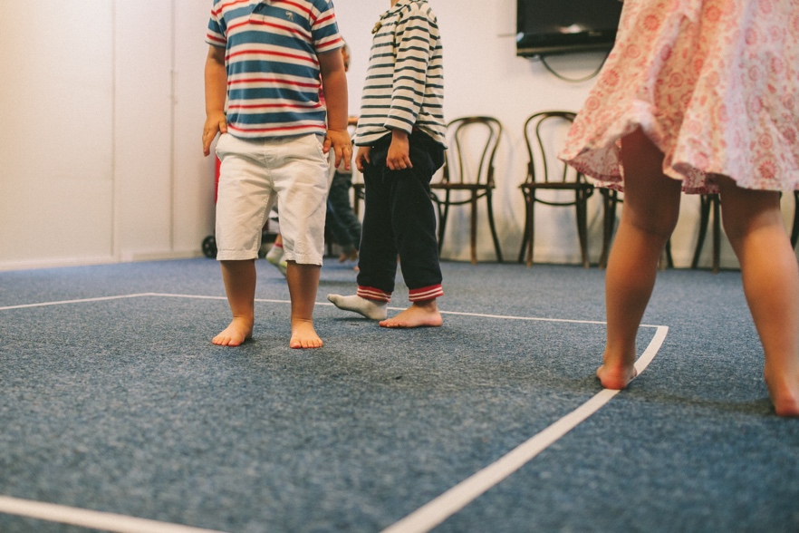

Be Vocal, Stay Visible
In our various guises as a freelancer despite working with lots of children teaching can be lonely and often frustrating. Accountability for our personal wellbeing is often realised too late. Practical solutions include taking care of your voice - it is the window of your profession after all! Breathing, water, steaming and time out from speaking are all helpful ingredients. Communicate your woes to a trusted friend. A listening ear is worth its weight in gold and can be reciprocal. Music teachers spend enormous energy and time on musical learning for children. But what about you? We often forget our own musical enjoyment too. Play and sing for yourself! The Musicians Union provides a great downloadable resource for health and wellbeing.

Vision, Positivity, Health.
Paradoxically a teacher's vision for excellent, musically achievable outcomes must include you first. Teachers who are constantly absent, ill-prepared or miserable are not actually selfless, committed or amazing at all. This may seem harsh but being professionally accountable and realistic can do much to help redress the balance of work and play. As an educator I know too well the downward spiralling of mental health, and how this can be avoided. Your vision for achieving outstanding musical outcomes in your children can be realised if you are in control. At the very least it is a start.

For a meaty read I recommend a couple of books to dig into at the bottom of this article. There, you will also find links to tips on avoiding stress and even a singing blog to cheer you up!

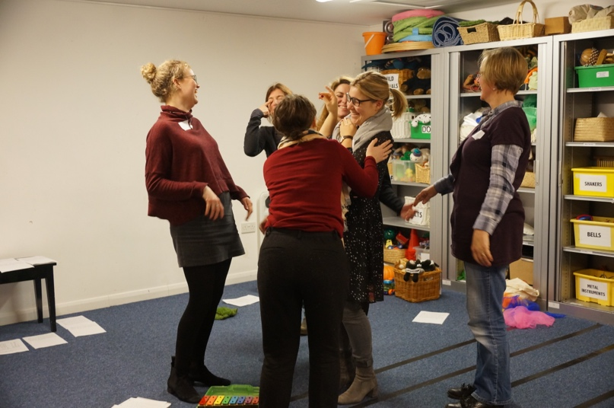

Useful Information and links
MacDonald, R. Kreutz, G. Mitchell, L. (2012). Music, Health and Wellbeing. Pub: OUP
Bethune, A. Kell, E. (2020). A little guide for teachers - Teacher Wellbeing and Self-Care Pub: Sage
Early Education
Cultural Diversity
MH Health guide
Stress Free Tips!
Singing Blogs

Emma is the founder of Music House for Children and specialist and trainer in early years music. Her training courses on Music House Courses offers courses, resources and know-how in teaching music to young children. Their ethos is collaborative, nurturing musical and social outcomes in joyful musical play.
emma@musichouseforchildren.com

www.musichouseforchildren.com
education@musichouseforchildren.com
@learnmusichouse
00 44 (0)20 8932 2652

