Monthly Health & Wellbeing Column
Music Teacher Magazine
January 2023

A Musical Framework
The language of our babies
In my earlier article we explored the intrinsic musicality of ourselves. If you are working with young children - whether teaching music or nurturing life skills - try to tap into your own music self to enable musicality and positive learning. The language our children learn from and speak is essentially musical (Link 1). If we can rethink how we listen and translate what we hear as music, we will undoubtedly become more in tune with what our children are trying to tell us. (Link 2). More importantly, how they (and we) can respond, consider, and learn with contentment.

There are three main approaches to accessing music in nursery settings.

A structured Musical Framework
Weekly music lessons involves a range of musical experiences. A good music template with lots of resources, and a relatable topic (think winter, celebration, and all things chilly), brings everyone together with playing, singing, moving and instrumental play and is fun and participatory, and on so many levels, good for everyone. (Link 3, p91). Structured music lessons are usually delivered by an external provider. Participation from supporting adults helps them understand music's significance and its place in children's lives. Participating also encourages the sharing of skills.

The government recommends regular music (Link 4 p:17) with early years settings sourcing external providers, individual specialists or accessing online resources. Unfortunately, two factors often impede regular music lessons: money and training. An unanswered question I constantly ask is this; why isn't music training embedded in early years training schemes? Surely this would create far less pressure on our collective purse strings, and provide educators with a positive collaborative platform?

Musical Islands©
Children with additional needs (cognitive and physical) respond to a flexible, non-pressured approach to music making. Musical Islands involves creating several music areas, each set up with a small collection of instruments or sound makers. The child chooses an area and explores without pressure to do or seemingly achieve specific outcomes. Musical Islands was devised to ascertain characteristics, and musical preferences by working from the child's strengths. The instrumental groups can be of a similar sound or material such as wood. This approach can be facilitated by an EY, SEND or music specialist, and is all about encouraging positive creative experiences.

Immersive Musical Play
Lively debates have raged for years about the value of spontaneous musical play versus structured, progressive lessons. Structured and non-structured (spontaneous) music making both carry welter-weight usefulness in the context of the child's overall development. Unstructured music will always be around however, because music is an intrinsic connection between the child, life experiences and subsequent learning. For example,

Spontaneous musical play can sound like this:
"Weeeeeeeeee, ooooooooooOOOOOOO. Aa Aa Aa... nee nor nee nor, nee nor.."

And a child's activity can look like this (as he makes those sounds):
'He traces his paintbrush along the paper, going up and up to the top corner, dabs his brush in another colour then splodges his brush to "Aa Aa Aa" before going up and down several times to conclude the journey.'

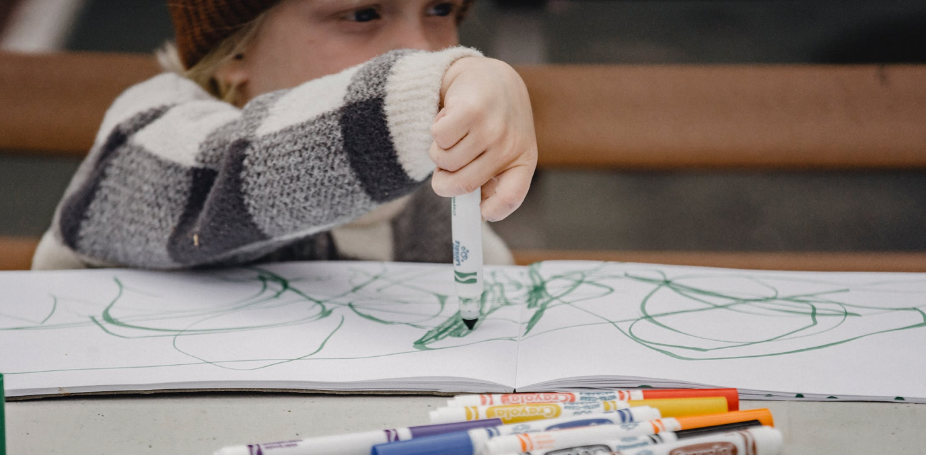

What is going on here? The 3 year old used sound play to move his brush, his imagination and choice of colour to create something meaningful, personal and memorable. His sound-play involved pitch and tempo, just like music. The child is learning about texture, colour, lines and dots, shapes, numbers and space, all whilst creating a story - on his terms. Imagine embellishing these musical moments to develop his experience still further. For example, offer another sound, or accompany him with a little drum beat or chime bar. The educational value is multi-facet.

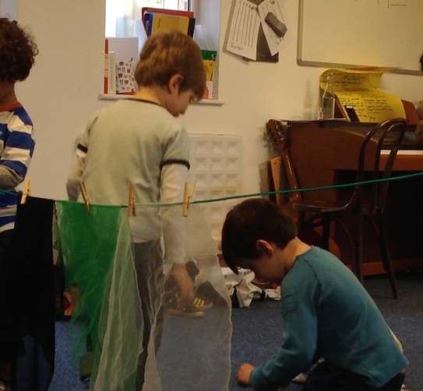

In this context you could support your children either as a music educator or early years specialist. That said, deciphering musical moments takes time, experience and ideally requires training in early childhood music to understand what a musical moment might look like, what the musical focus is, how it happened, where it is going, and what the outcomes might be. (Link 5, Link 6)

Pocket Songs
Pocket songs are a sweet, spontaneous way of enhancing wellbeing, positive atmosphere or calming a tricky moment with young children. They are short songs or rhymes to drop in anytime to encourage a shared moment or bring to life a new resource such as an instrument, or to translate to other areas of learning with building blocks, a new book or outdoor play. They are memorable, often in rhyming couplets, and provide opportunities for silly sounds, response, and a certain amount of funniness. You never know; some of the examples might encourage you to create new pocket songs! (Link 7).

One thing we can all agree on is that music plays an undisputed role in exuding all those jolly chemicals called endorphins. Music learning is about music. However, the outcomes go far deeper and last far longer than simply learning about the subject, the instruments and how to sing.

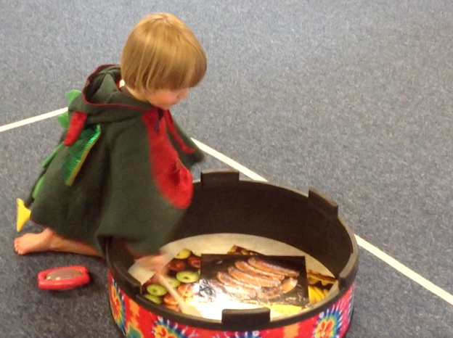

The next article will discuss Music and Accountability, and the role of the music educators in ever-changing communities.

Downloadable links
1/ Music as a language by Emma Hutchinson

2/ Pre-birth to three: Professor Colwyn Trevarthen – Musicality of Language

3/ Little Birdsong Music Book 1: Music lesson template: page 91

4/ The power of music to change lives: a national plan for music education, p. 17

5/ Early years music training - CREC: Certificate for Music Educators: Early childhood

6/ Early years music training - Music House Courses: Music in the Early Years

7/ Pocket songs – Music House for Children: downloadable MP3's

Information on Music House for Children:
We are a non-profit music school based in London specialising in musical learning, communicative and life skills in babies, young children and those with additional needs and language delay. We have a collaborative ethos with a flexible framework and approach to reaching, engaging and supporting individuals to maximise socio emotional and musical outcomes.

Emma Hutchinson
emma@musichouseforchildren.com
www.musichouseforchildren.com
@learnmusichouse
00 44 (0)20 8932 2652

Special Educational Needs & Disabilities

